You have to submit this report via Moodle.
Use a zip file or tarball that contains the report and all other files you used for the report, i.e., the entire Verilog project folder and/or all schematics you drew. If any files are missing, it may negatively impact your grade. No shortcuts/links will be accepted.
Digital Design and Computer Architecture: Lab Report
Lab 1: Drawing Basic Circuits
Date |  | Grade
Names | Mario Malis, Fabian Rohlik
 |  | Lab session / lab room

Only one of the members of each group should submit. All members of the group will get the same grade.
The name of the submitted file should be Lab1_LastName1_LastName2.zip (or .tar), where LastName1 and LastName2 are the last names of the members of the group.
The deadline for the report is a hard deadline and it will not be extended.

Exercise 1 (1.5 Pts)
(a) Assume that we were only using 2-input AND gates and 2-input XNOR gates to create our comparator in Part 1 in this week’s lab manual. How many of each gate would you use for a comparator of width 8, 16, 32 and 64 bits? What is the logic depth in each case?
Note: The logic depth of a combinational circuit is defined as the number of basic logic gates (e.g., AND, OR, NOT, XOR, etc.) in the longest signal path (path from input to output). The width of the comparator indicates the number of bits of each input signal to compare.

Comparator Width | 2-input XNOR gates | 2-input AND gates | Logic depth
8 bits | 8 | 7 | 4
16 bits | 16 | 15 | 5
32 bits | 32 | 31 | 6
64 bits | 64 | 63 | 7

(b) Given the comparator width is N, derive general expressions for calculating the following:
(i) The number of 2-input XNOR gates: $N$

(ii) The number of 2-input AND gates: $N-1$

(iii) The logic depth: $1 + \left\lceil \log_{2}{N}\right\rceil$

Exercise 2 (1 Pts)
Use two instances of the 1-bit comparator we designed in Part 2 in this week’s lab to implement a 2-bit comparator. Draw the schematic of your design.
Make sure to include the schematic of your 1-bit comparator so we can verify your solution.
Note: You can either draw on a paper like in the lab session or use a tool such as circuitlab.com to draw a schematic on your computer.

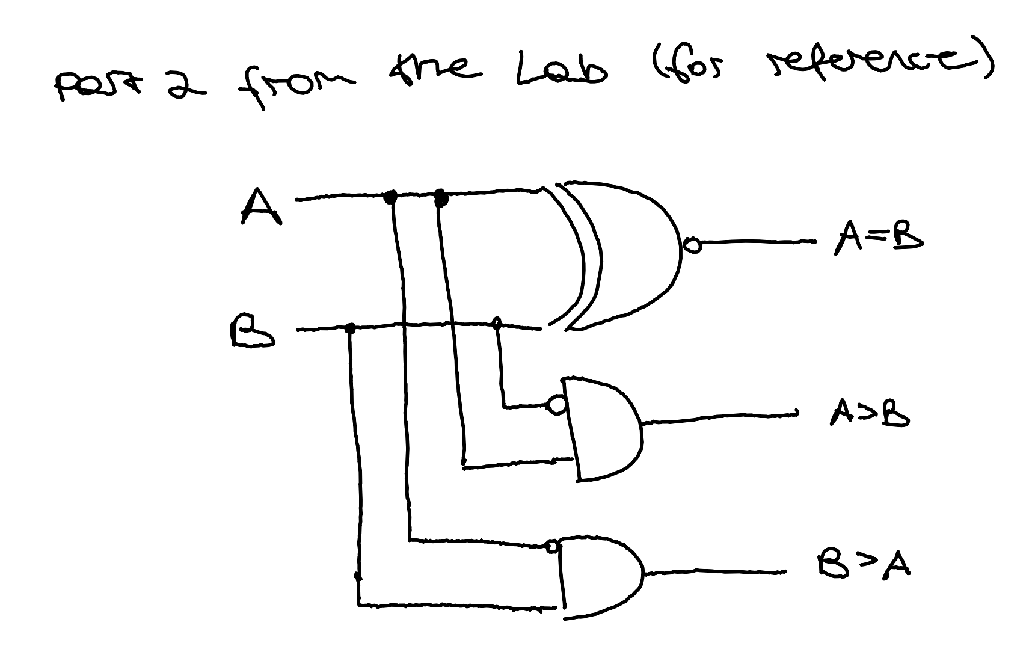

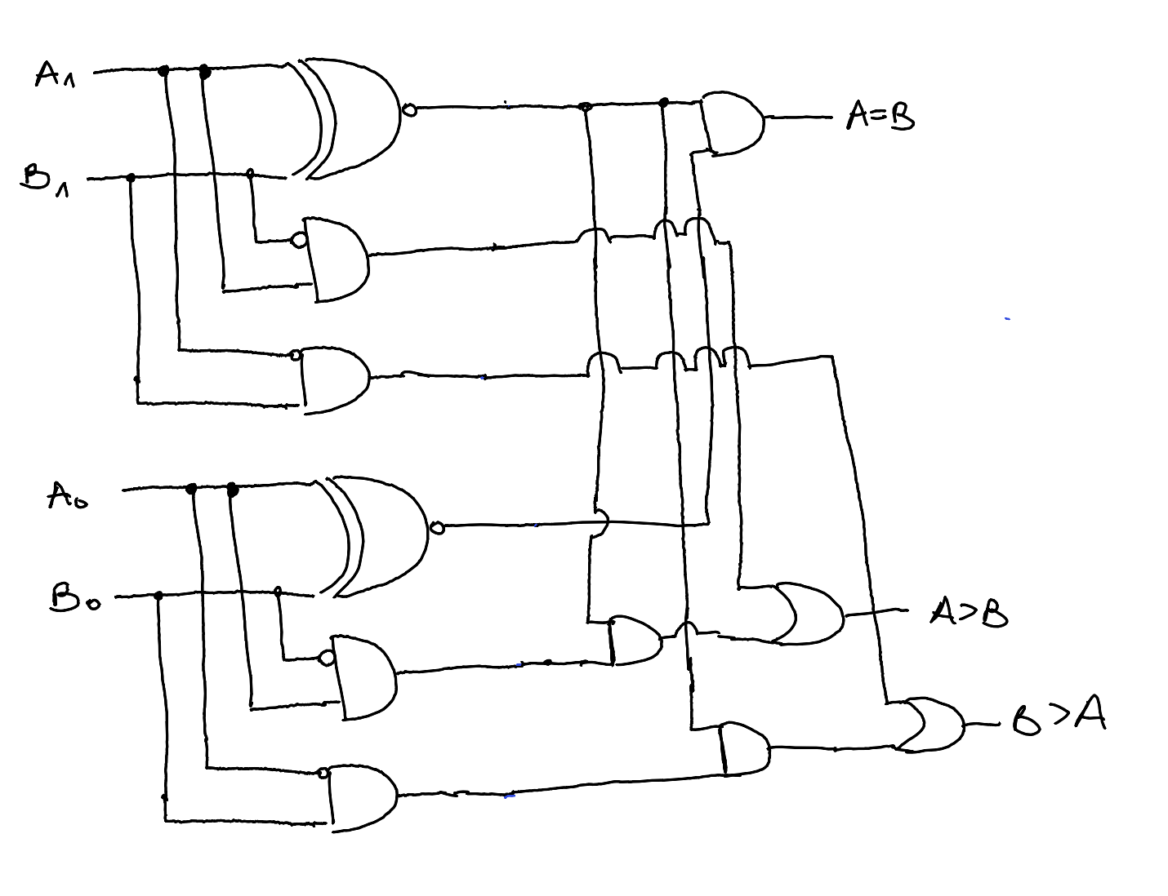
Here, we use $A_{1}$ as the left digit and $A_{0}$ as the right digit, analogously for B.

Exercise 3 (0.5 Pts)
What is the logic depth of each of the output ports in the circuit of Exercise 2?
Note: You need to calculate the logic depth of an output port based on the path that contains the highest number of basic logic gates from the inputs to the output port.

Here, we count the usage of the not-bubble in front of a gate, f.ex. as in 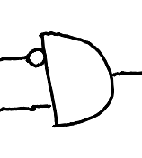, as its own not gate.

Equality: depth 2
A>B: depth 4
B>A: depth 4

